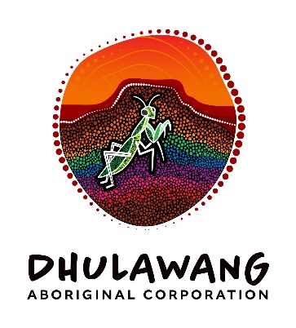

# Dhulawang Aboriginal Corporation

# Job Advertisement

**Independent Director (Family dispute resolution)**

**Location:** Flexible (Remote or On-Country engagement options available)  
**Term:** Part-time, fixed-term (initial 12 months, with potential for extension)  
**Remuneration:** Negotiable  
**Reports to:** Chairperson, Dhulawang Aboriginal Corporation

**About Dhulawang Aboriginal Corporation**

Dhulawang Aboriginal Corporation is a First Nations-led organisation committed to empowering Aboriginal families in Kempsey and on the Mid-North Coast of NSW. As a Dunghutti-led entity, Dhulawang champions self-determination, community-led governance, and long-term prosperity for families in need. The three key streams of our business include Family Dispute Resolution, Domestic Violence and NDIS.

**Role Overview**

We are seeking an experienced Independent Director with a strong background in family dispute resolution to join our Board and support Dhulawang in strengthening governance, culturally safe practice, and strategic decision-making. This role is critical to ensuring the Corporation’s alignment with best practice standards in delivering family dispute resolution services (in line with our grant funding from the Attorney General’s Department), mediation and community engagement.

**Key Responsibilities**

* Provide independent oversight and strategic advice on family dispute resolution practices, frameworks, and service delivery.
* Support the Board in developing and implementing culturally safe and trauma-informed governance approaches.
* Assist in interpreting service data and ensuring compliance with relevant legal and ethical obligations.
* Contribute to board discussions with a focus on family wellbeing, conflict resolution, and community empowerment.
* Mentor and build capacity within the Board and executive team in dispute resolution and culturally responsive practice.
* Uphold the values and cultural integrity of Dhulawang Aboriginal Corporation

**Essential Criteria**

* Proven experience as an accredited family dispute resolution practitioner, board director or senior executive in a community organisation or family relationship centre, or related fields.
* Professional qualifications in family dispute resolution, social work, law, or a related discipline.
* Demonstrated understanding of legal and governance principles regarding family dispute resolution service design.
* Experience working with Aboriginal organisations or in culturally safe environments.
* Strong communication, conflict resolution, and interpersonal skills.
* Commitment to ethical leadership and community empowerment.

**Desirable**

* Knowledge of Indigenous governance models and community-controlled organisations.
* Experience in not-for-profit or social enterprise sectors.
* Familiarity with funding bodies, grant management, and financial reporting in the Aboriginal sector.

**How to Apply**

Please submit your CV and a cover letter outlining your interest and suitability for the role to Laura Curtin, General Manager at [operations@dhulawang.com.au](mailto:operations@dhulawang.com.au)